TRAIN RESERVATION SYSTEM
Project Documentation

Submitted To:
Sir Laeeq Khan
Submitted By:
Ali Umair
Roll No: BSCS-2026-95

Department of Computer Science

1. Functional Requirements
This section describes all the features and operations that users of the Train Reservation System can perform. The system has two types of users: Admin and Passenger.

1.1 Admin Functionalities
The admin has full control over the system. Following are the admin's functional requirements:
- Admin can login using username and password with limited attempts (3 tries)
- Admin can search any train by its name
- Admin can add a new train with all details (name, route, time, fare, seats)
- Admin can view a complete revenue report for all trains
- Admin can view all bookings made in the system
- Admin can cancel any passenger's booking and issue a refund
- Admin can view a graphical train occupancy report with percentage bar
- Admin can logout from the system securely

1.2 Passenger Functionalities
Passengers are the end-users who book and manage their train tickets. Following are the passenger's functional requirements:
- Passenger can view all available trains with route and fare details
- Passenger can register a new account (name, age, password) to book a ticket
- Passenger can search and select a train for booking
- Passenger can confirm or cancel the booking before finalizing
- Passenger can view all their past and active bookings by name
- Passenger can cancel an active booking and receive a refund amount
- Passenger receives a unique booking number upon successful reservation

2. Wireframes
Wireframes are the visual screenshots of the application showing the actual running output of the program. Each menu and feature screen is captured below with a short description.

Wireframe 1 – Main Menu (Home Screen)
The starting screen of the application. User chooses Admin, Passenger, or Exit.
- Option 1: Admin Portal
- Option 2: Passenger Portal
- Option 3: Exit
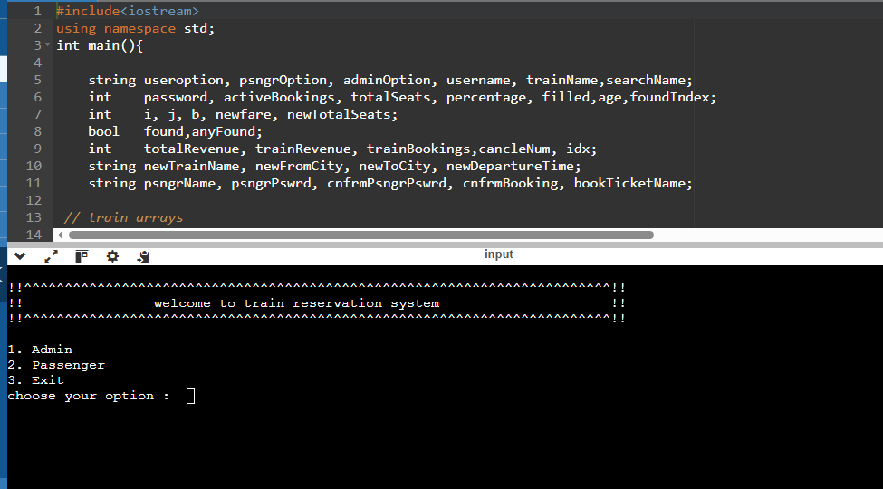

Wireframe 2 – Admin Login Screen
Admin authentication screen with limited login attempts for security.
- Username field
- Password field
- Attempt counter displayed
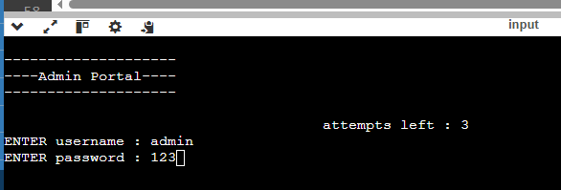

Wireframe 3 – Admin Menu
Main admin dashboard showing all available administrative options.
- Search Train
- Add New Train
- Total Revenue Report
- View All Bookings
- Cancel Booking
- Occupancy Report
- Logout
[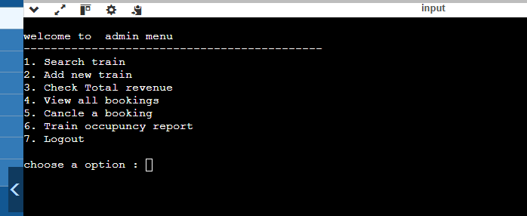

Wireframe 4 – Passenger Menu
Passenger dashboard with options to view trains, book, and manage tickets.
- View All Trains
- Book a Ticket
- View My Bookings
- Cancel My Ticket
- Exit
[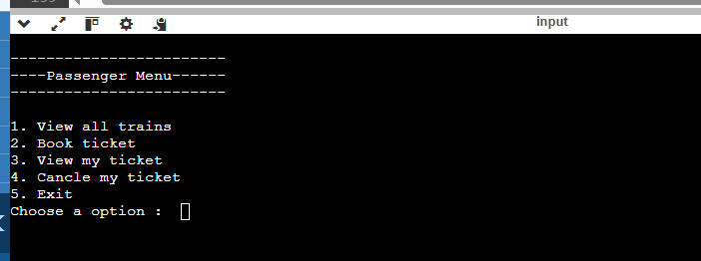

Wireframe 5 – Train Occupancy Report
Visual bar chart showing how many seats are booked versus available for each train.
- Train name and route shown
- Booked/total seats count
- Progress bar using # and - characters
- Percentage occupancy displayed
[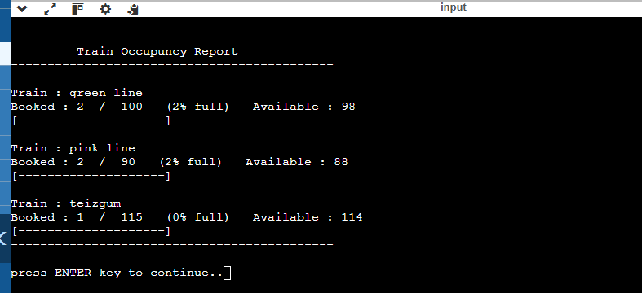

3. Data Structures
The Train Reservation System uses parallel arrays as its primary data structure. All related data across multiple arrays is linked by the same index. For example, trainArray[0], fromCityArray[0], fareArray[0] all belong to the same train. Below is a complete table of all arrays and variables used:

Variable Name | Data Type | Description / Role
trainArray[10] | string | Stores names of all trains (e.g., green line)
fromCityArray[10] | string | Stores departure city for each train
toCityArray[10] | string | Stores destination city for each train
departureArray[10] | string | Stores departure time for each train (HH:MM format)
fareArray[10] | int | Stores ticket fare (PKR) for each train
seatsArray[10] | int | Stores current available seats for each train
totalTrains | int | Counter for total number of trains in system
nameArray[100] | string | Stores names of all registered passengers
ageArray[100] | int | Stores age of each registered passenger
psngrPassArray[100] | string | Stores password of each registered passenger
totalPassengers | int | Counter for total number of registered passengers
bookedByArray[100] | string | Stores passenger name against each booking
bookedTrainArray[100] | string | Stores train name against each booking
bookedFareArray[100] | int | Stores fare amount paid for each booking
bookingStatusArray[100] | string | Stores status of each booking (active / cancelled)
totalBookings | int | Counter for total number of bookings ever made

3.1 How Parallel Arrays Work
Index 0 of each array represents the first train. All its properties — name, from city, to city, departure time, fare, and available seats — are stored at index 0 in their respective arrays. The same logic applies to passengers and bookings. This technique is called a Parallel Array data structure.

4. Source Code
Below is the complete enhanced source code of the Train Reservation System written in C++. The output formatting has been improved using setw() and iomanip for clean, aligned tables and menus.

train_reservation_system.cpp
#include<iostream>
#include<iomanip>
using namespace std;

void printLine(char c = '=', int len = 70){
for(int i=0;i<len;i++) cout<<c;
cout<<endl;
}

void printHeader(string title){
printLine('=');
int pad = (70 - title.length()) / 2;
cout<<setw(pad+title.length())<<title<<endl;
printLine('=');
}

void printSubHeader(string title){
printLine('-');
int pad = (70 - title.length()) / 2;
cout<<setw(pad+title.length())<<title<<endl;
printLine('-');
}

int main(){

string useroption, psngrOption, adminOption, username, trainName,searchName;
int password, activeBookings, totalSeats, percentage, filled,age,foundIndex;
int i, j, b, newfare, newTotalSeats;
bool found,anyFound;
int totalRevenue, trainRevenue, trainBookings,cancleNum, idx;
string newTrainName, newFromCity, newToCity, newDepartureTime;
string psngrName, psngrPswrd, cnfrmPsngrPswrd, cnfrmBooking, bookTicketName;

// train arrays
string trainArray[10] = {"green line", "orange line", "teizgum"};
string fromCityArray[10] = {"lahore", "peshawer", "pindi"};
string toCityArray[10] = {"karachi", "quetta", "lahore"};
string departureArray[10] = {"06:00", "12:00", "18:00"};
int fareArray[10] = {2500, 2000, 1000};
int seatsArray[10] = {100, 90, 115};
int totalTrains = 3;

// passenger arrays
string nameArray[100] = {"ali","sara","ahmad","fatima","usman"};
int ageArray[100] = {25,32,19,27,35};
string psngrPassArray[100] = {"ali123","sara456","ahmed789","fatima321","usman654"};
int totalPassengers = 5;

// booking arrays
string bookedByArray[100] = {"ali","sara","ahmed","fatima","ali","usman"};
string bookedTrainArray[100] = {"green line","orange line","green line","teizgum","teizgum","orange line"};
int bookedFareArray[100] = {2500,2000,2500,1000,1000,2000};
string bookingStatusArray[100] = {"active","active","active","active","cancelled","active"};
int totalBookings = 6;

seatsArray[0] = 98;
seatsArray[1] = 88;
seatsArray[2] = 114;

while(true){
cout<<endl;
printLine('*');
cout<<"*"<<setw(34)<<"TRAIN RESERVATION SYSTEM"<<setw(34)<<"*"<<endl;
cout<<"*"<<setw(34)<<"Pakistan Railways"<<setw(34)<<"*"<<endl;
printLine('*');
cout<<endl;
cout<<" [1] Admin Portal"<<endl;
cout<<" [2] Passenger Portal"<<endl;
cout<<" [3] Exit"<<endl;
cout<<endl;
cout<<" Choose your option: ";
cin>>useroption;

if(useroption=="1"){
cout<<endl;
printHeader(" ADMIN LOGIN ");
cout<<endl;
for(i=3;i>0;i--){
cout<<" Attempts remaining: "<<i<<endl;
cout<<" Username : ";
cin>>username;
cout<<" Password : ";
cin>>password;
if(username=="admin" && password==123){
while(true){
cout<<endl;
printHeader(" ADMIN MENU ");
cout<<endl;
cout<<" [1] Search Train"<<endl;
cout<<" [2] Add New Train"<<endl;
cout<<" [3] Total Revenue Report"<<endl;
cout<<" [4] View All Bookings"<<endl;
cout<<" [5] Cancel a Booking"<<endl;
cout<<" [6] Train Occupancy Report"<<endl;
cout<<" [7] Logout"<<endl;
cout<<endl<<" Choose an option: ";
cin>>adminOption;

if(adminOption=="1"){
cout<<endl;
printSubHeader(" SEARCH TRAIN ");
cout<<" Enter train name: ";
cin.ignore();
getline(cin,trainName);

foundIndex = -1; found = false;
for(j=0;j<totalTrains;j++){
if(trainName==trainArray[j]){ found=true; foundIndex=j; }
}
if(found){
cout<<endl;
cout<<" "<<left<<setw(16)<<"Train"<<setw(12)<<"From"<<setw(12)<<"To"<<setw(12)<<"Departs"<<setw(10)<<"Fare"<<setw(10)<<"Seats"<<endl;
printLine('-');
cout<<" "<<left<<setw(16)<<trainArray[foundIndex]<<setw(12)<<fromCityArray[foundIndex]<<setw(12)<<toCityArray[foundIndex]<<setw(12)<<departureArray[foundIndex]<<setw(10)<<fareArray[foundIndex]<<setw(10)<<seatsArray[foundIndex]<<endl;
}else{
cout<<endl<<" [!] Train not found."<<endl;
}

}else if(adminOption=="2"){
cout<<endl;
printSubHeader(" ADD NEW TRAIN ");
cout<<" Train name : "; cin.ignore(); getline(cin,newTrainName);
cout<<" Departure city : "; cin>>newFromCity;
cout<<" Destination city : "; cin>>newToCity;
cout<<" Departure time : "; cin>>newDepartureTime;
cout<<" Fare (PKR) : "; cin>>newfare;
cout<<" Total seats : "; cin>>newTotalSeats;

if(totalTrains < 10){
trainArray[totalTrains] = newTrainName;
fromCityArray[totalTrains] = newFromCity;
toCityArray[totalTrains] = newToCity;
departureArray[totalTrains] = newDepartureTime;
fareArray[totalTrains] = newfare;
seatsArray[totalTrains] = newTotalSeats;
cout<<endl<<" [+] Train added successfully!"<<endl;
cout<<endl;
cout<<" "<<left<<setw(16)<<"Train"<<setw(12)<<"From"<<setw(12)<<"To"<<setw(12)<<"Departs"<<setw(10)<<"Fare"<<setw(10)<<"Seats"<<endl;
printLine('-');
cout<<" "<<left<<setw(16)<<trainArray[totalTrains]<<setw(12)<<fromCityArray[totalTrains]<<setw(12)<<toCityArray[totalTrains]<<setw(12)<<departureArray[totalTrains]<<setw(10)<<fareArray[totalTrains]<<setw(10)<<seatsArray[totalTrains]<<endl;
totalTrains++;
}else{
cout<<endl<<" [!] Train list is full. Cannot add more trains."<<endl;
}

}else if(adminOption=="3"){
cout<<endl;
printHeader(" TOTAL REVENUE REPORT ");
cout<<endl;
cout<<" "<<left<<setw(18)<<"Train"<<setw(14)<<"Bookings"<<setw(16)<<"Revenue (PKR)"<<endl;
printLine('-');
totalRevenue = 0;
for(i=0;i<totalTrains;i++){
trainRevenue=0; trainBookings=0;
for(j=0;j<totalBookings;j++){
if(bookedTrainArray[j]==trainArray[i] && bookingStatusArray[j]=="active"){
trainRevenue += bookedFareArray[j];
trainBookings++;
}
}
cout<<" "<<left<<setw(18)<<trainArray[i]<<setw(14)<<trainBookings<<setw(16)<<trainRevenue<<endl;
totalRevenue += trainRevenue;
}
printLine('-');
cout<<" "<<left<<setw(18)<<"TOTAL REVENUE"<<setw(14)<<""<<"PKR "<<totalRevenue<<endl;
printLine('=');

}else if(adminOption=="4"){
cout<<endl;
printHeader(" ALL BOOKINGS ");
cout<<endl;
if(totalBookings==0){
cout<<" No bookings found."<<endl;
}else{
cout<<" "<<left<<setw(5)<<"No."<<setw(14)<<"Passenger"<<setw(16)<<"Train"<<setw(10)<<"Fare"<<setw(12)<<"Status"<<endl;
printLine('-');
for(i=0;i<totalBookings;i++){
cout<<" "<<left<<setw(5)<<(i+1)<<setw(14)<<bookedByArray[i]<<setw(16)<<bookedTrainArray[i]<<setw(10)<<bookedFareArray[i]<<setw(12)<<bookingStatusArray[i]<<endl;
}
}
printLine('=');

}else if(adminOption=="5"){
cout<<endl;
printHeader(" CANCEL A BOOKING ");
cout<<endl;
if(totalBookings==0){
cout<<" No bookings found."<<endl;
}else{
cout<<" "<<left<<setw(5)<<"No."<<setw(14)<<"Passenger"<<setw(16)<<"Train"<<setw(10)<<"Fare"<<setw(12)<<"Status"<<endl;
printLine('-');
for(i=0;i<totalBookings;i++){
cout<<" "<<left<<setw(5)<<(i+1)<<setw(14)<<bookedByArray[i]<<setw(16)<<bookedTrainArray[i]<<setw(10)<<bookedFareArray[i]<<setw(12)<<bookingStatusArray[i]<<endl;
}
printLine('-');
cout<<endl<<" Enter booking number to cancel (0 = back): ";
cin>>cancleNum;
if(cancleNum==0){
// go back
}else if(cancleNum<1 || cancleNum>totalBookings){
cout<<" [!] Invalid booking number."<<endl;
}else{
idx = cancleNum - 1;
if(bookingStatusArray[idx]=="cancelled"){
cout<<" [!] This booking is already cancelled."<<endl;
}else{
bookingStatusArray[idx] = "cancelled";
for(i=0;i<totalTrains;i++){
if(trainArray[i]==bookedTrainArray[idx]){ seatsArray[i]++; break; }
}
cout<<endl<<" [+] Booking #"<<cancleNum<<" cancelled successfully."<<endl;
cout<<" Refund Amount: PKR "<<bookedFareArray[idx]<<endl;
}
}
}

}else if(adminOption=="6"){
cout<<endl;
printHeader(" TRAIN OCCUPANCY REPORT ");
for(i=0;i<totalTrains;i++){
activeBookings=0;
for(j=0;j<totalBookings;j++){
if(bookedTrainArray[j]==trainArray[i] && bookingStatusArray[j]=="active") activeBookings++;
}
totalSeats = seatsArray[i] + activeBookings;
percentage = (totalSeats > 0) ? (activeBookings*100)/totalSeats : 0;
cout<<endl;
cout<<" Train : "<<trainArray[i]<<endl;
cout<<" Booked : "<<activeBookings<<" / "<<totalSeats<<" ("<<percentage<<"% full) Available: "<<seatsArray[i]<<endl;
filled = percentage / 5;
cout<<" [";
for(b=0;b<20;b++) cout<<(b<filled ? '#' : '-');
cout<<"] "<<percentage<<"%"<<endl;
printLine('-');
}

}else if(adminOption=="7"){
cout<<endl<<" Logging out..."<<endl;
printLine();
break;
}else{
cout<<endl<<" [!] Invalid option. Please try again."<<endl;
cin.ignore(); cin.get();
}
}
break;
}else if(i==1){
cout<<endl<<" [!] Invalid username or password. Access denied."<<endl;
cin.ignore(); cin.get(); break;
}else{
cout<<endl<<" [!] Invalid credentials. Please try again."<<endl<<endl;
}
}

}else if(useroption=="2"){
while(true){
cout<<endl;
printHeader(" PASSENGER MENU ");
cout<<endl;
cout<<" [1] View All Trains"<<endl;
cout<<" [2] Book a Ticket"<<endl;
cout<<" [3] View My Bookings"<<endl;
cout<<" [4] Cancel My Ticket"<<endl;
cout<<" [5] Exit"<<endl;
cout<<endl<<" Choose an option: ";
cin>>psngrOption;

if(psngrOption=="1"){
cout<<endl;
printSubHeader(" AVAILABLE TRAINS ");
cout<<endl;
cout<<" "<<left<<setw(16)<<"Train"<<setw(12)<<"From"<<setw(12)<<"To"<<setw(12)<<"Departs"<<setw(10)<<"Fare"<<setw(10)<<"Seats"<<endl;
printLine('-');
for(i=0;i<totalTrains;i++){
cout<<" "<<left<<setw(16)<<trainArray[i]<<setw(12)<<fromCityArray[i]<<setw(12)<<toCityArray[i]<<setw(12)<<departureArray[i]<<setw(10)<<fareArray[i]<<setw(10)<<seatsArray[i]<<endl;
}
printLine('=');

}else if(psngrOption=="2"){
while(true){
cout<<endl;
printSubHeader(" BOOK A TICKET - REGISTER ");
cout<<" Enter your name : "; cin.ignore(); getline(cin,psngrName);
cout<<" Create password : "; cin>>psngrPswrd;
cout<<" Confirm password : "; cin>>cnfrmPsngrPswrd;

if(psngrPswrd==cnfrmPsngrPswrd){
cout<<" Enter your age : "; cin>>age;
cout<<endl;
cout<<" "<<left<<setw(16)<<"Train"<<setw(12)<<"From"<<setw(12)<<"To"<<setw(12)<<"Departs"<<setw(10)<<"Fare"<<setw(10)<<"Seats"<<endl;
printLine('-');
for(i=0;i<totalTrains;i++){
cout<<" "<<left<<setw(16)<<trainArray[i]<<setw(12)<<fromCityArray[i]<<setw(12)<<toCityArray[i]<<setw(12)<<departureArray[i]<<setw(10)<<fareArray[i]<<setw(10)<<seatsArray[i]<<endl;
}
cout<<endl<<" Enter train name to book: "; cin.ignore(); getline(cin,bookTicketName);

foundIndex=-1; found=false;
for(i=0;i<totalTrains;i++){
if(bookTicketName==trainArray[i]){ found=true; foundIndex=i; }
}
if(found){
if(seatsArray[foundIndex]<=0){
cout<<endl<<" [!] Sorry, no seats available on this train."<<endl;
}else{
cout<<endl;
printSubHeader(" BOOKING SUMMARY ");
cout<<" Passenger : "<<psngrName<<endl;
cout<<" Train : "<<trainArray[foundIndex]<<endl;
cout<<" From : "<<fromCityArray[foundIndex]<<" -> "<<toCityArray[foundIndex]<<endl;
cout<<" Departs : "<<departureArray[foundIndex]<<endl;
cout<<" Fare : PKR "<<fareArray[foundIndex]<<endl;
printLine('-');
cout<<" Confirm booking? (1=Yes / 0=No): ";
cin>>cnfrmBooking;

if(cnfrmBooking=="1"){
nameArray[totalPassengers] = psngrName;
ageArray[totalPassengers] = age;
psngrPassArray[totalPassengers] = psngrPswrd;
totalPassengers++;

bookedByArray[totalBookings] = psngrName;
bookedTrainArray[totalBookings] = trainArray[foundIndex];
bookedFareArray[totalBookings] = fareArray[foundIndex];
bookingStatusArray[totalBookings] = "active";
totalBookings++;
seatsArray[foundIndex]--;

cout<<endl<<" [+] Booking confirmed successfully!"<<endl;
cout<<" Your Booking Number: #"<<totalBookings<<endl;
printLine('=');
}else{
cout<<" Booking cancelled."<<endl;
}
}
}else{
cout<<endl<<" [!] Train not found."<<endl;
cin.ignore(); cin.get();
}
break;
}else{
cout<<endl<<" [!] Passwords do not match. Please try again."<<endl<<endl;
}
}

}else if(psngrOption=="3"){
cout<<endl;
printSubHeader(" VIEW MY BOOKINGS ");
cout<<" Enter your name: "; cin.ignore(); getline(cin,searchName);
cout<<endl;
anyFound=false;
for(i=0;i<totalBookings;i++){
if(bookedByArray[i]==searchName){
cout<<" Booking No. : #"<<(i+1)<<endl;
cout<<" Passenger : "<<bookedByArray[i]<<endl;
cout<<" Train : "<<bookedTrainArray[i]<<endl;
cout<<" Fare : PKR "<<bookedFareArray[i]<<endl;
cout<<" Status : "<<bookingStatusArray[i]<<endl;
printLine('-');
anyFound=true;
}
}
if(!anyFound) cout<<" [!] No bookings found for this name."<<endl;
printLine('=');

}else if(psngrOption=="4"){
cout<<endl;
printSubHeader(" CANCEL MY TICKET ");
cout<<" Enter your name: "; cin.ignore(); getline(cin,searchName);
cout<<endl;
anyFound=false;
for(i=0;i<totalBookings;i++){
if(bookedByArray[i]==searchName && bookingStatusArray[i]=="active"){
cout<<" #"<<(i+1)<<" Train: "<<bookedTrainArray[i]<<" Fare: PKR "<<bookedFareArray[i]<<" Status: "<<bookingStatusArray[i]<<endl;
anyFound=true;
}
}
if(!anyFound){
cout<<" [!] No active bookings found."<<endl;
}else{
cout<<endl<<" Enter booking number to cancel (0 = back): ";
cin>>cancleNum;
if(cancleNum!=0){
if(cancleNum<1 || cancleNum>totalBookings){
cout<<" [!] Invalid booking number."<<endl;
}else{
idx = cancleNum-1;
if(bookedByArray[idx]!=searchName){
cout<<" [!] This booking does not belong to you."<<endl;
}else if(bookingStatusArray[idx]=="cancelled"){
cout<<" [!] This booking is already cancelled."<<endl;
}else{
bookingStatusArray[idx]="cancelled";
for(i=0;i<totalTrains;i++){
if(trainArray[i]==bookedTrainArray[idx]){ seatsArray[i]++; break; }
}
cout<<endl<<" [+] Booking cancelled successfully."<<endl;
cout<<" Refund Amount: PKR "<<bookedFareArray[idx]<<endl;
}
}
}
}
printLine('=');

}else if(psngrOption=="5"){
break;
}else{
cout<<endl<<" [!] Invalid option."<<endl;
cin.ignore(); cin.get();
}
}

}else if(useroption=="3"){
cout<<endl;
printLine('*');
cout<<" Thank you for using Train Reservation System!"<<endl;
printLine('*');
break;
}else{
cout<<endl<<" [!] Invalid option. Please try again."<<endl;
cin.ignore(); cin.get();
}
}
return 0;
}

